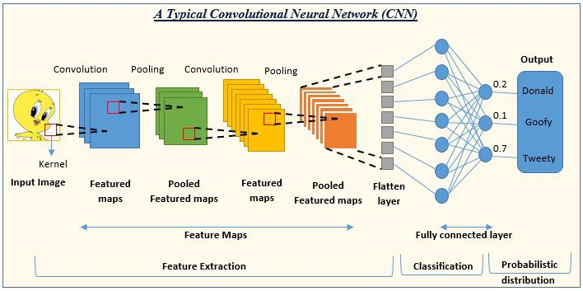

* **Convolutional Neural Networks (CNNs)**: CNNs are effective for image-based environmental monitoring, such as identifying and classifying species in wildlife images or detecting pollution in satellite images.
* **Recurrent Neural Networks (RNNs)**: RNNs can be used for time-series data analysis, making them suitable

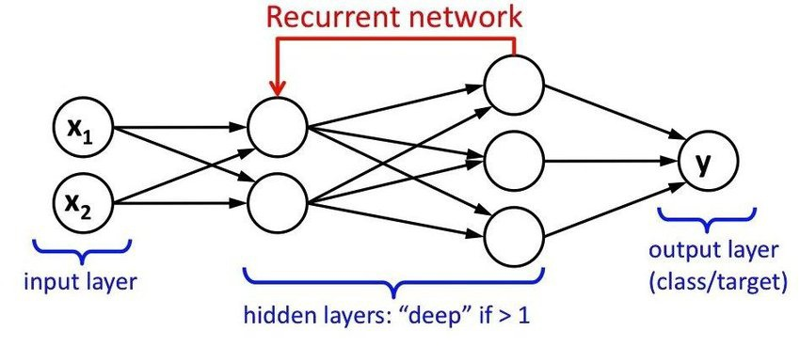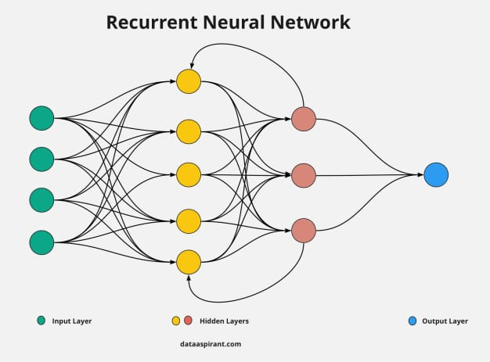

for applications like weather forecasting and air quality prediction.

* **Random Forests and Decision Trees**: These are useful for classification

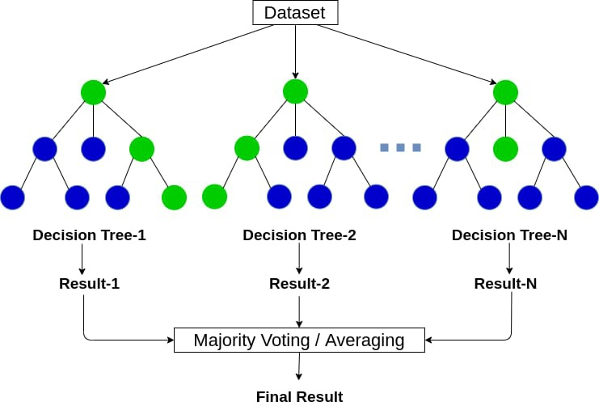

tasks, like identifying land use or cover types in remote sensing data.

* **Deep Reinforcement Learning**: This can be applied to optimize resource management in environmental monitoring, such as controlling autonomous drones for data collection.

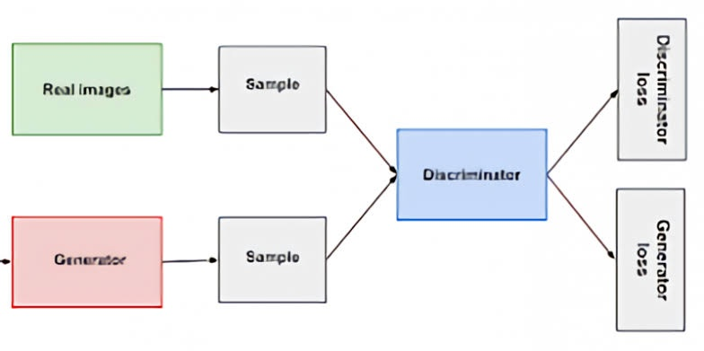

* **Generative Adversarial Networks (GANs)**: GANs can be used to generate synthetic environmental data, which can be valuable for augmenting real datasets and training machine learning models.

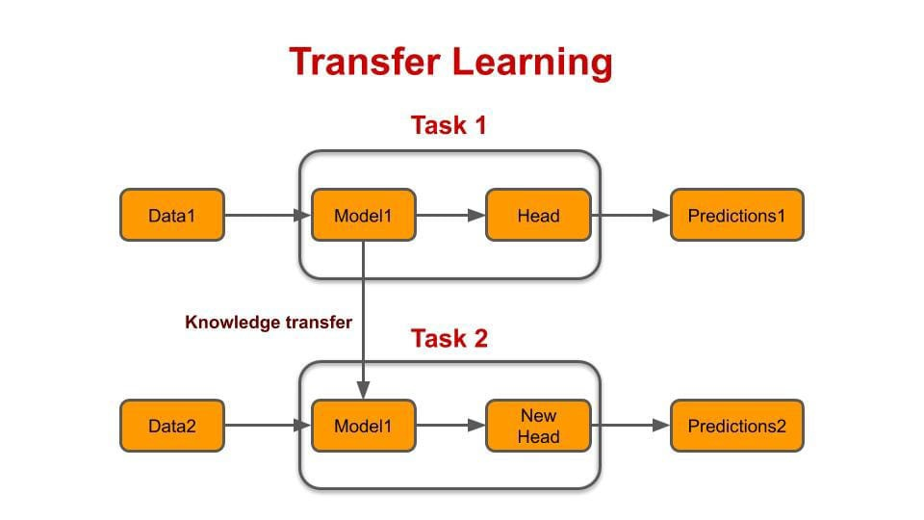

* **Transfer Learning**: Leveraging pre-trained models, like BERT or GPT, can be beneficial for natural language processing tasks related to environmental data, such as sentiment analysis of public opinions on environmental issues.

* **Anomaly Detection Algorithms**: Algorithms like Isolation Forests or One-Class SVMs can help identify unusual patterns or anomalies in

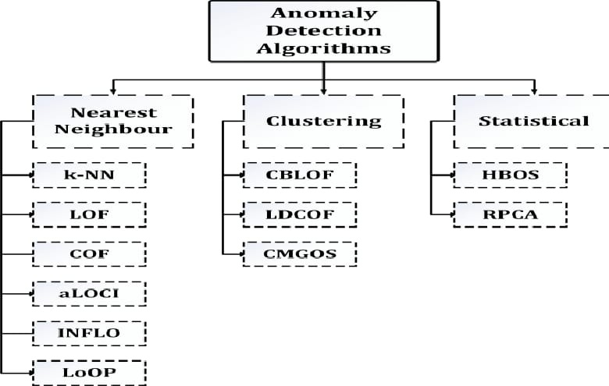

environmental data, which could indicate issues like equipment malfunctions or pollution incidents.

* **Ensemble Methods**: Combining multiple machine learning models can improve prediction accuracy and robustness in various environmental monitoring applications

